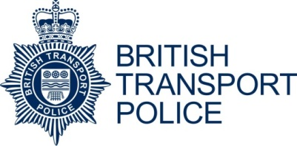

DIVERSITY MONITORING FORM

British Transport Police is an equal opportunities employer and is determined to ensure that:

- The workforce reflects the diverse society which it serves and that the working environment is free from any form of harassment, intimidation, bullying or victimisation.
- No job applicant or employee is treated more or less favourable on the grounds of age, colour, disability, ethnic origin, family commitments, gender, gender dysphoria, marital status – marriage or civil partnership, nationality, national origins, political beliefs, race, religion or belief, sexual orientation, trade union activity or any other unacceptable grounds.
- No job applicant or employee is disadvantaged by conditions or requirements which cannot be justified by the requirements of the job.

The information on this form is for monitoring purposes only and will not be made available to those assessing your application. The information supplied will be treated in the strictest confidence and will not affect your job application in any way. Completion of this form is voluntary but the information will help us ensure equality of opportunity. This information forms no part of the selection process and it will be detached from your application on receipt.

Ethnic Origin |  |  |  | Religious Belief / Faith
White | British |  |  | Buddhist
 | Irish |  |  | Christian
 | Any other white background |  |  | Hindu
Mixed | White and Black Caribbean |  |  | Jewish
 | White and Black African |  |  | Muslim
 | White and Asian |  |  | Sikh
 | Any other mixed background |  |  | Other
Asian or Asian British | Indian |  |  | None
 | Pakistani |  |  | Prefer not to say
 | Bangladeshi |  |  | Sexual Orientation
 | Any other Asian background |  |  | Bisexual
Black or Black British | Caribbean |  |  | Gay / Lesbian
 | African |  |  | Heterosexual
 | Any other Black background |  |  | Prefer not to say
Chinese or other ethnic group | Chinese |  |  | Gender
 | Other |  |  | Male
 | Prefer not to say |  |  | Female
 |  |  |  | Prefer not to say
Date of Birth | DD/MM/YYYY
Disability | The Equality Act 2010 defines disability as a ‘physical or mental impairment which has substantial and long term adverse effect’ on your day to day living. Do you consider yourself to have a disability?
 | Yes | No |  | Prefer not to say
 | If you answered yes please identify which category the disability falls into:
 | Hearing, speech or visual impairment
 | Coordination, dexterity or mobility
 | Speech impairment
 | Learning disability
 | Cognitive impairment
 | Other physical or medical condition
 | Prefer not to say

